SKILL WEEK- 8
Session – 15
TASK 1: TO Parse Combined Redirection, Duplicate File Descriptors, Merge Streams, Verify Ordering, Handle Edge Cases, Test Integrated Outputs
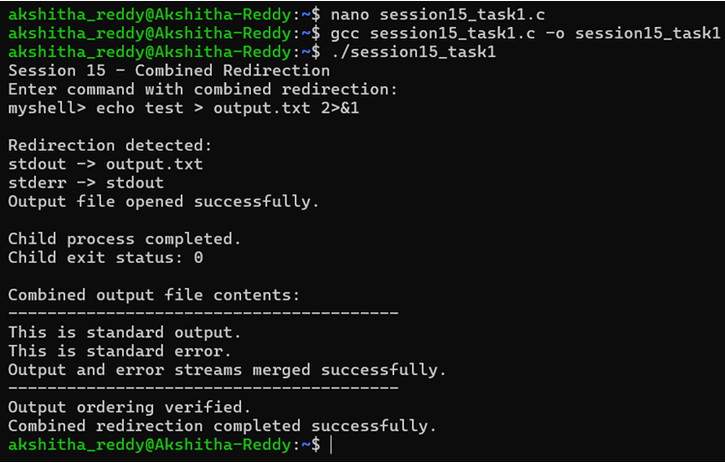
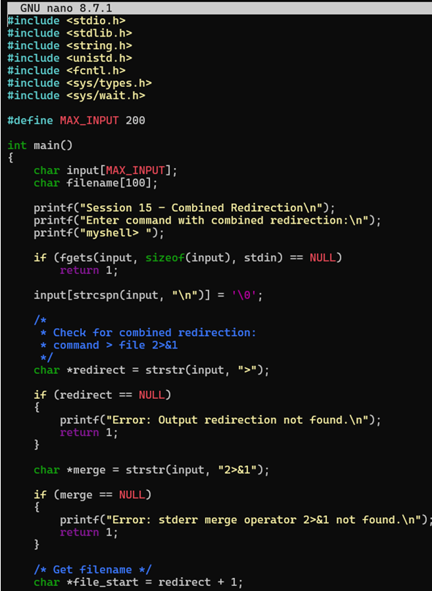
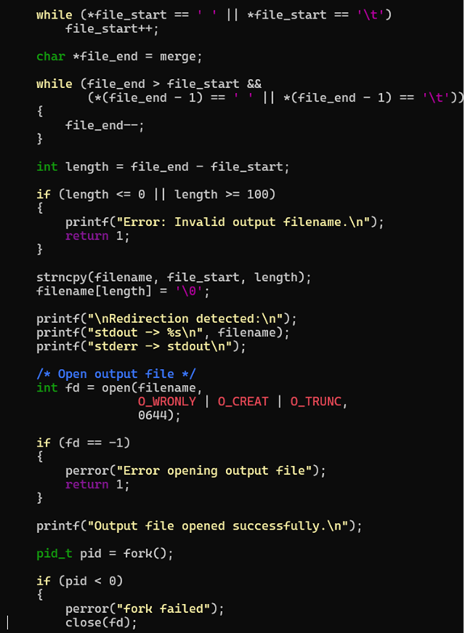
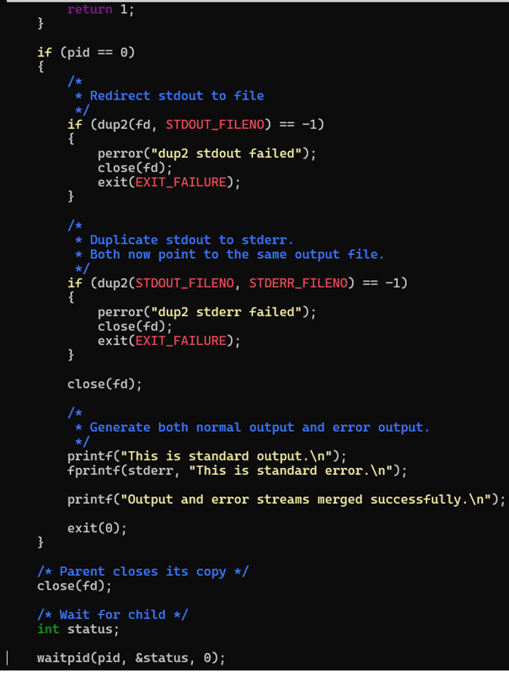
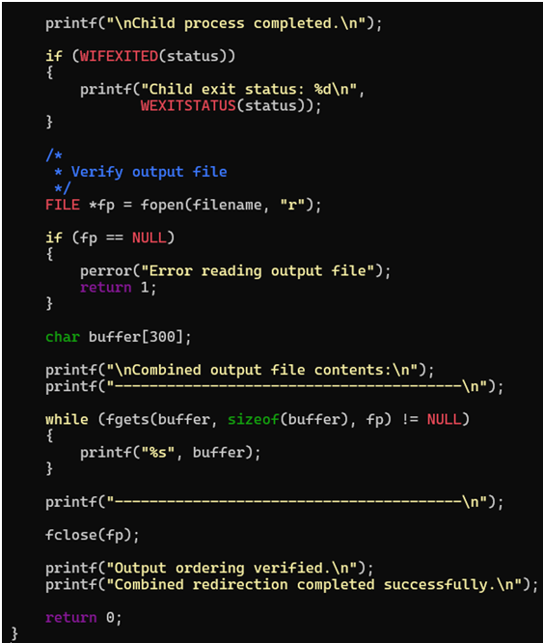
Task 2: To Parse Complex Commands, Combine Pipes and Redirections, Resolve Execution Order, Validate Syntax, Generate Execution Plans, Test Scenarios
